[Star_flash.gif](http://maps.google.com/?ie=UTF8&t=h&ll=40.728421,-91.96063&spn=0.003037,0.004801&z=18)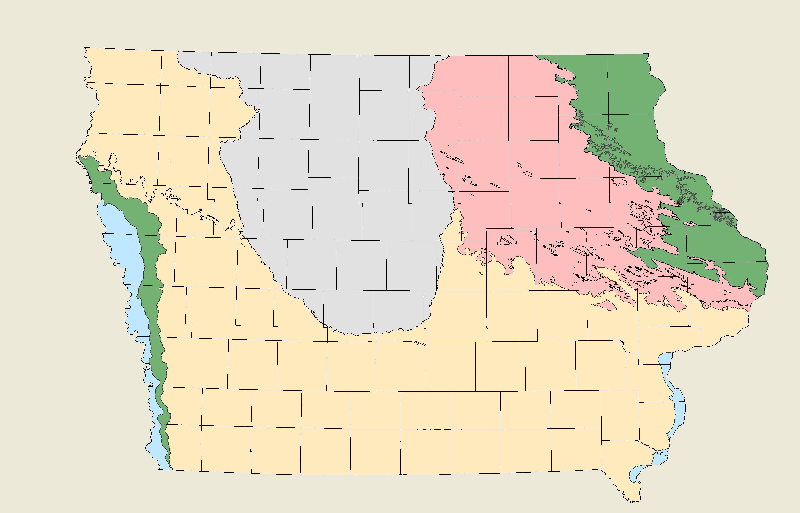

Location: Test Shaft #1 - Hwy 1 over Des Moines River, North Abutment

Soil Regions

Alluvium

Loess

Wisconsin Glacial

Loamy Glacial

Loess on top of Glacial

Click on the star to view satellite pictures of the test site location.

FREMONT

MILLS

PAGE

MONTGOMERY

TAYLOR

ADAMS

RINGGOLD

UNION

DECATUR

CLARKE

WAYNE

LUCAS

APPANOOSE

MONROE

DAVIS

WAPELLO

VAN BUREN

JEFFERSON

LEE

HENRY

DES MOINES

LOUISA

WASHINGTON

KEOKUK

MAHASKA

MARION

WARREN

MADISON

ADAIR

CASS

POTTAWATTAMIE

HARRISON

SHELBY

AUDUBON

GUTHRIE

DALLAS

POLK

JASPER

POWESHIEK

IOWA

JOHNSON

MUSCATINE

CEDAR

SCOTT

CLINTON

JACKSON

JONES

LINN

BENTON

TAMA

MARSHALL

STORY

BOONE

GREENE

CARROLL

CRAWFORD

MONONA

WOODBURY

IDA

SAC

CALHOUN

WEBSTER

HAMILTON

HARDIN

GRUNDY

BLACK HAWK

BUCHANAN

DELAWARE

DUBUQUE

CLAYTON

FAYETTE

BREMER

BUTLER

FRANKLIN

WRIGHT

HUMBOLDT

POCAHONTAS

BUENA VISTA

CHEROKEE

PLYMOUTH

SIOUX

O’BRIEN

CLAY

PALO ALTO

HANCOCK

CERRO GORDO

FLOYD

CHICKASAW

OSCEOLA

DICKINSON

EMMET

KOSSUTH

WINNEBAGO

WORTH

MITCHELL

HOWARD

WINNESHIEK

ALLAMAKEE

LYON

Click on star to view satellite pictures.